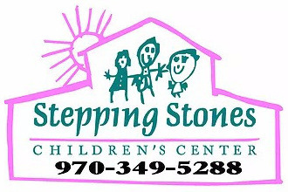

Stepping Stones Children’s Center
2019-2020 SCHOOL YEAR & SUMMER CALENDAR

DATE | DESCRIPTION | HOLIDAY
Monday August 26, 2019 | First day of 2018-19 fiscal school year
Monday September 2, 2019 | CLOSED | Labor Day
Monday October 14, 2019 | CLOSED | Columbus Day
Thursday October 31, 2019 | Halloween Bash 10:30-12:30 at S.S. | Halloween
Friday November 22, 2019 | Thanksgiving Feast 11:30-12:30 | Thanksgiving
Thursday November 28, 2019 | CLOSED | Thanksgiving Day
Friday November 29, 2019 | CLOSED | Thanksgiving Holiday
TBA | Santa Visits and party | Christmas
December 24 + 25 | CLOSED | Christmas Break
Monday January 1, 2020 | CLOSED | New Year’s Day
Monday February 17, 2020 | CLOSED | President’s Day
TBA | 5:30-7 PM | Art show/performance
Mon-Fri. April 20-24, 2020 | CLOSED | Spring Break
Monday May 25, 2020 | CLOSED | Memorial Day
Friday June 5, 2020 | Last day of 2019-20 fiscal school year
Monday June 8, 2020 | First Day of Summer Program | Summer!
Tuesday August 18, 2020 | Last Day of Summer Program
Wed-Fri. August 19-21, 2020 | CLOSED | Teacher work week and School year readiness
Monday August 24, 2020 | First Day of 2020-21 Fiscal School Year

