SUMMER 2021 CALENDAR &
SCHOOL YEAR 2021-22
Subject to Change
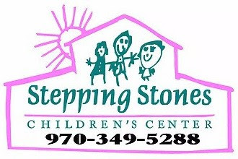

DATE | DESCRIPTION | HOLIDAY
Thursday June 10, 2021 | First Day of Summer session
Monday July 5, 2021 | CLOSED | July 4th
Tuesday August 17, 2021 | Last day of Summer Session
Wednesday-Friday  August 18-20, 2021 | CLOSED | Teacher workdays and school year readiness
Monday August 23, 2021 | First day of 2021-22 fiscal school year
Monday September 6, 2021 | CLOSED | Labor Day
Monday October 11, 2021 | CLOSED | Indigenous People’s Day
TBA | Halloween Bash 10:30-12:00 | Halloween
TBA | Thanksgiving Feast 11:30-12:30 | Thanksgiving
November 25 + 26, 2021 | CLOSED | Thanksgiving
TBA | Santa Visits and party | Christmas

December 24, 2021 | CLOSED | Christmas Eve
Friday December 31, 2021 | CLOSED | New Year’s Eve
Monday January 17, 2022 | CLOSED | MLK Day
Monday February 14, 2022 | CLOSED | President’s Day
Mon-Fri. April 18-22, 2022 | CLOSED | Spring Break
Monday May 30, 2022 | CLOSED | Memorial Day
Friday June 3, 2022 | Last Day of School year and Graduation
Monday-Wednesday June 6-8, 2022 | CLOSED | Teacher workdays and summer readiness
Thursday June 9, 2022 | First day of summer session

